Clayton DeSimone

Thesis/Capstone

Final Project

5/2/2024

Below is an outline of the structure of the HHAA website that my mom (Gayle Josin) and I put together.

**Outline Of Helena Hunters**

**& Angers Association Website**

KEY to this outline:

**MAIN PAGE,**

**A - 1st SUB-PAGE**

**A1 - Sub-Headings**

**A1a - Individual Items**

**HOME**

**Helena Hunter and Anglers Association**

**Our Mission**

**We are Passionate**

* **Learn More [button]**

**Contact Us**

* **Address and email [button]**

**A – ABOUT**

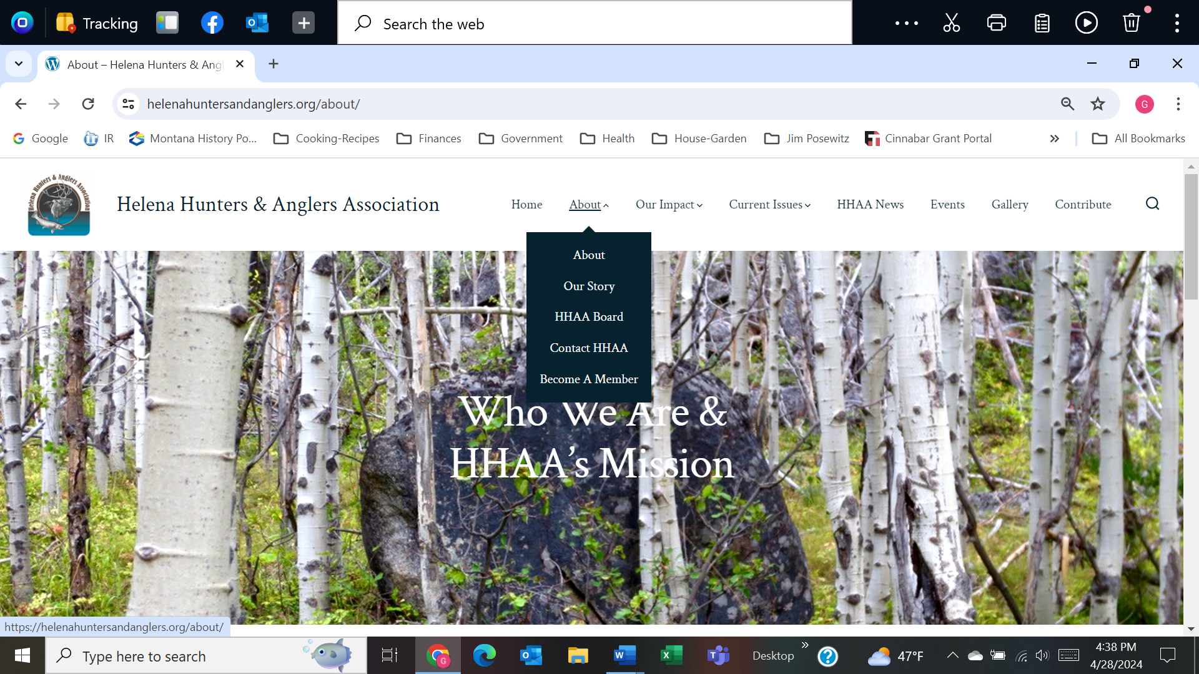

**A1 - ABOUT -- WHO WE ARE & HHAA’s MISSION**

**A1a – Who We Are**

* Cinnabar and WELC logos linked to their webpages
* Mission
* Become a Member

**A2b – HHAA Mission**

**A2 – OUR STORY -- Our Story**

A2a – Our Story

A2b – Our Founder

* Jim Posewitz
* Jim’s Books
* Jim’s Quote

**A3 – HHAA BOARD -- MEET OUR HHAA BOARD** (9 Board Members)

* President
* Vice President
* Treasurer
* Secretary
* Board member (5)
* Board member (6)
* Board member (7)
* Board member (8)
* Board member (9)

**A4 – CONTACT HHAA -- GET INVOLVED**

A3a – Contact

A3b – Email [button]

A3c – Mail

A3d – Facebook

**A5 – BECOME A MEMBER -- BECOME AN HHAA MEMBER** [diverts to CONTRIBUTE page]

A4a – Membership

* Costs
  + Download form to mail in
  + Pay on-line [button]

A4b – Be A Contributor

* + Donate [button]

**B – OUR IMPACT -- OUR IMPACT**

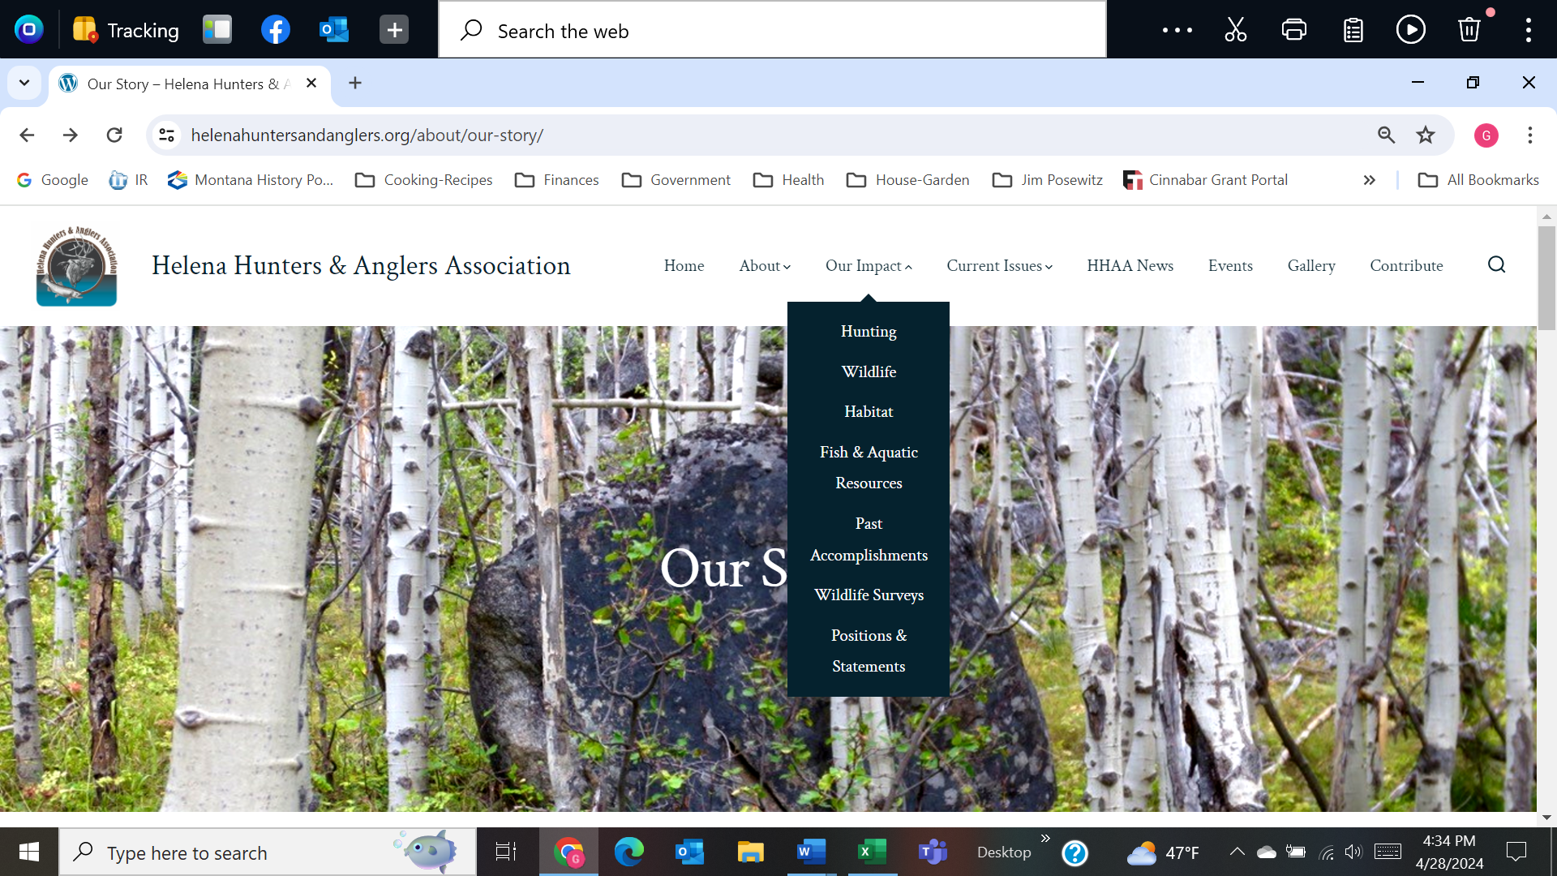

**B1 – HUNTING**

**B1a – Our Impact: Hunting**

* North American Model of Wildlife Conservation
* In Defense of Hunting

**B1b – Hunting Seasons**

* Elk Management Plan
* MFWP for Hunting information

**B1c – Shoulder Seasons**

* [Bob Ream Comments on Elk Shoulder Seasons](https://helenahuntersandanglers.org/wp-content/uploads/2020/10/Comments-on-Elk-Shoulder-Seasons-Bob-Ream.pdf)
* [HHAA Comment August 10, 2015](https://helenahuntersandanglers.org/wp-content/uploads/2020/10/Elk-Shoulder-Seasons-2015-HHAA-comment.pdf)
* [HHAA Comment January 18, 2019](https://helenahuntersandanglers.org/wp-content/uploads/2020/10/Elk-Shoulder-Season-HHAA-Comments-1-18-2019.pdf)
* [HHAA Comment December 4, 2019](https://helenahuntersandanglers.org/wp-content/uploads/2020/10/Elk-Shoulder-Seasons-12-4-2019.pdf)
* [Montana Land Ownership, Elk Distribution, Hunt Districts and Private Lands Leased to Outfitters](https://helenahuntersandanglers.org/wp-content/uploads/2020/10/Montana-Land-Ownership-Elk-Distribution-Outfitting-Map.pdf)

**B1d – Mandatory Reporting**

* [Comment by HHAA to MFWP regarding Mandatory Reporting April 5, 2018](https://helenahuntersandanglers.org/wp-content/uploads/2020/10/Mandatory-Reporting-4-5-2018_Ingman-to-MacDonald.pdf)

**BB1 - WILDLIFE**

**BB1a – Bison Restoration**

**BB1b – Wildlife Reports/Information**

**BB1c – SENSITIVE, THREATENED AND ENDANGERED SPECIES**

* **Wolverine**

**BB1d – Recreation Impact References**

**BB1e – Wildlife Disease**

**B2 – HABITAT**

#### **B2a -** **Big Game Security – the heart of HHAA advocacy**

**B2ab – Travel Management**

**B2ab1 – Divide Travel Plan**

**B2ab2 – Blackfoot Travel Plan**

**B2b – Inventoried Roadless Areas**

**B2c – Elkhorn Wildlife Management Unit**

**B2d – Wildlife Management Areas**

**B2e – Wildlife Connectivity & Continental Divide**

**B3 – FISH & AQUATIC RESOURCES**

**B4 – PAST ACCOMPLISHMENTS** *(Litigation/Policy-refer back to OUR IMPACT/Wildlife & Habitat)*

* **Wolverine Status 1**
* **Tenmile-South Helena Project 2**
* **Divide Travel Plan Intervention 3**
* **Tenmile-South Helena Vegetation Project [7-1-2020] 4**
* **Bear Hair Collection – Grizzly Bear Distribution Project 5**
* **Big Game Security Amendment [10-17-2015] 6**
* **Wildlife Connectivity – MacDonald Pass Biathlon Challenge 7**
* **MT Fish & Wildlife Conservation Trust 8**
* **1986 Citizens Initiative for Helena Forest Plan 9**

**B5 – WILDLIFE SURVEYS**

* **Bear Hair Snagging [2008-2012]** refer to Past Accomplishments
* **Species of Interest**

**B6 – POSITIONS and STATEMENTS**

**C – CURRENT ISSUES**

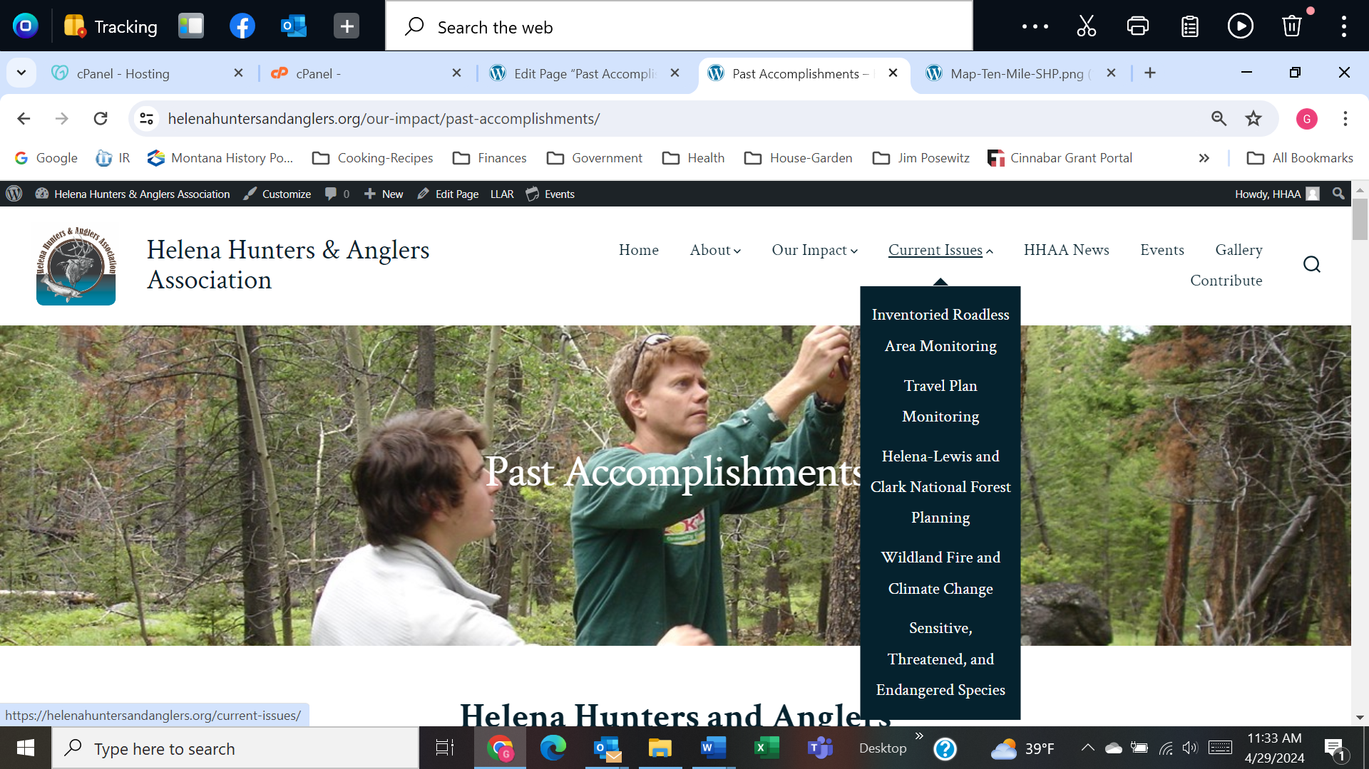

**C1 – INVENTORIED ROADLESS AREA MONITORING  *refers back to OUR IMPACT/Habitat***

**C2 –****TRAVEL PLAN MONITORING on HELENA NATIONAL FOREST**

**C2a – Blackfoot Travel Plan**

**C2b – Divide Travel Plan**

**C3 – HELENA-LEWIS & CLARK NATIONAL FOREST PLANNING**

**C4 – WILDLAND FIRE & CLIMATE CHANGE**

**C5 – SENSITIVE, THREATENED and ENDANGERED SPECIES**

**C6 – MONTANA LEGISLATURE 2025 [hide the page for now]**

**D – HHAA NEWS**

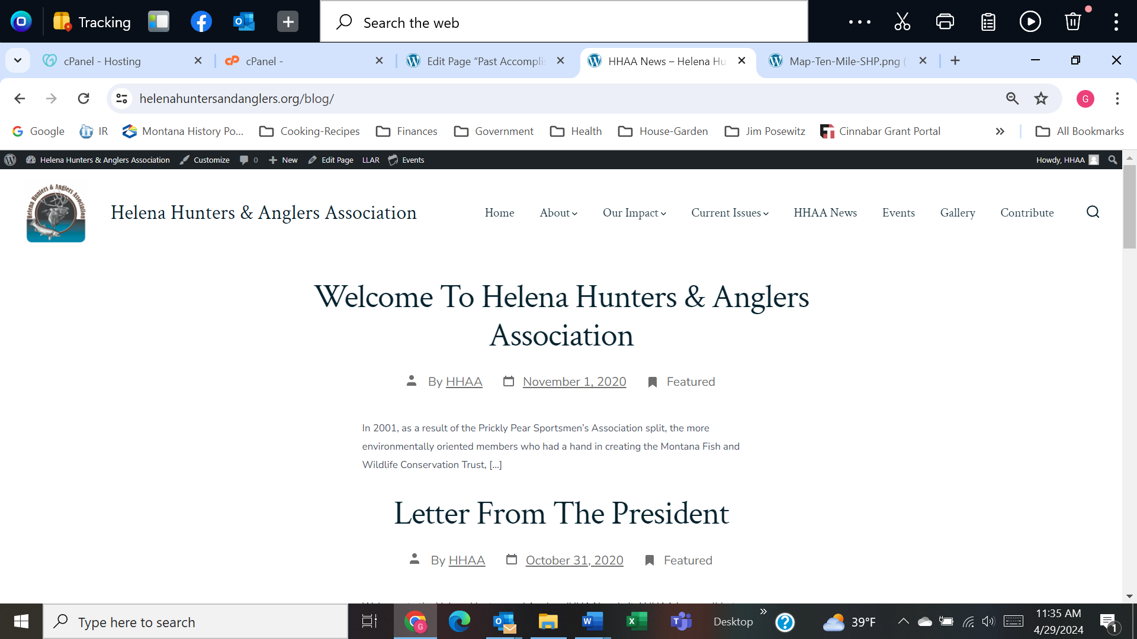

* Welcome to Helena Hunters & Anglers Association
* Letter from the President
* Montana Matters Youth Outdoor Experience
* Climate change Rule-Making Petition to MT Public Service Commission
* North American wolverine receives federal protection as a threatened species under the Endangered Species Act (Nov 2023)
* Montanans Intervene in Lawsuit Attacking State Management of Elk (June 2022)
* Court again forces feds to reconsider wolverine protections, this time using science (2022)
* Helena Hunters move to defend the Forest Service’s Divide Travel Plan (2022)
* Support for Wild Bison in Montana (May 2021)
* Montana Outdoor Hall of Fame – HHAA Members (2020)

**E – EVENTS Calendar**

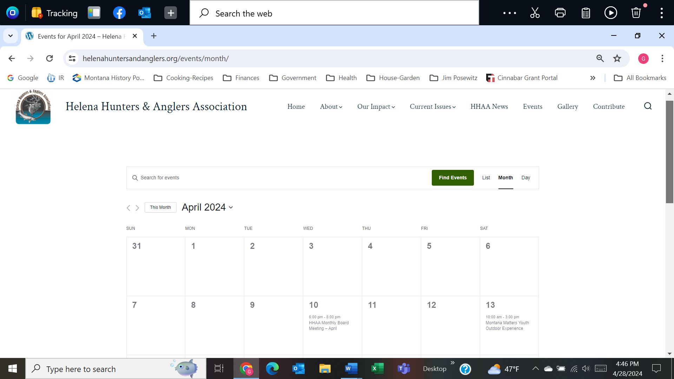

**F – GALLERY** Contact us for permission to use photos (button}

* **G1-Wildlife**
* **Gx-Hunting, Angling and Recreating**
* **G2-Landscapes**
  + G2a-Landscape Damage (not posted)
* G3-Members & Volunteers (not posted)

**G – CONTRIBUTE -- Become an HHAA Member and Contributor**

* Membership -
  + Download form [button]
  + Pay online [button]
* Be a Contributor
  + Donation [button]